Spriggins, Don (notes mainly from Bush fire Front website)
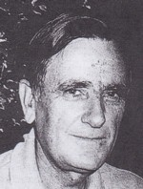
Over 40 years experience in bushfire management in WA and Victoria. Assistant Forester 1956-59 with Victoria Forests Commission. Joined Forests Department in 1962. District Forests Officer at Dwellingup, Kelmscott-Jarrahdale, transferred to Collie in 1972. CALM Regional Manager Central Forest Region in 1980s. Member of the Forests Production Council and long-time Chairman of the Institute of Foresters (W.A. Division). Fellow of the IFA. Retired c2000. Consultant since retirement. Volunteer with CALM.

